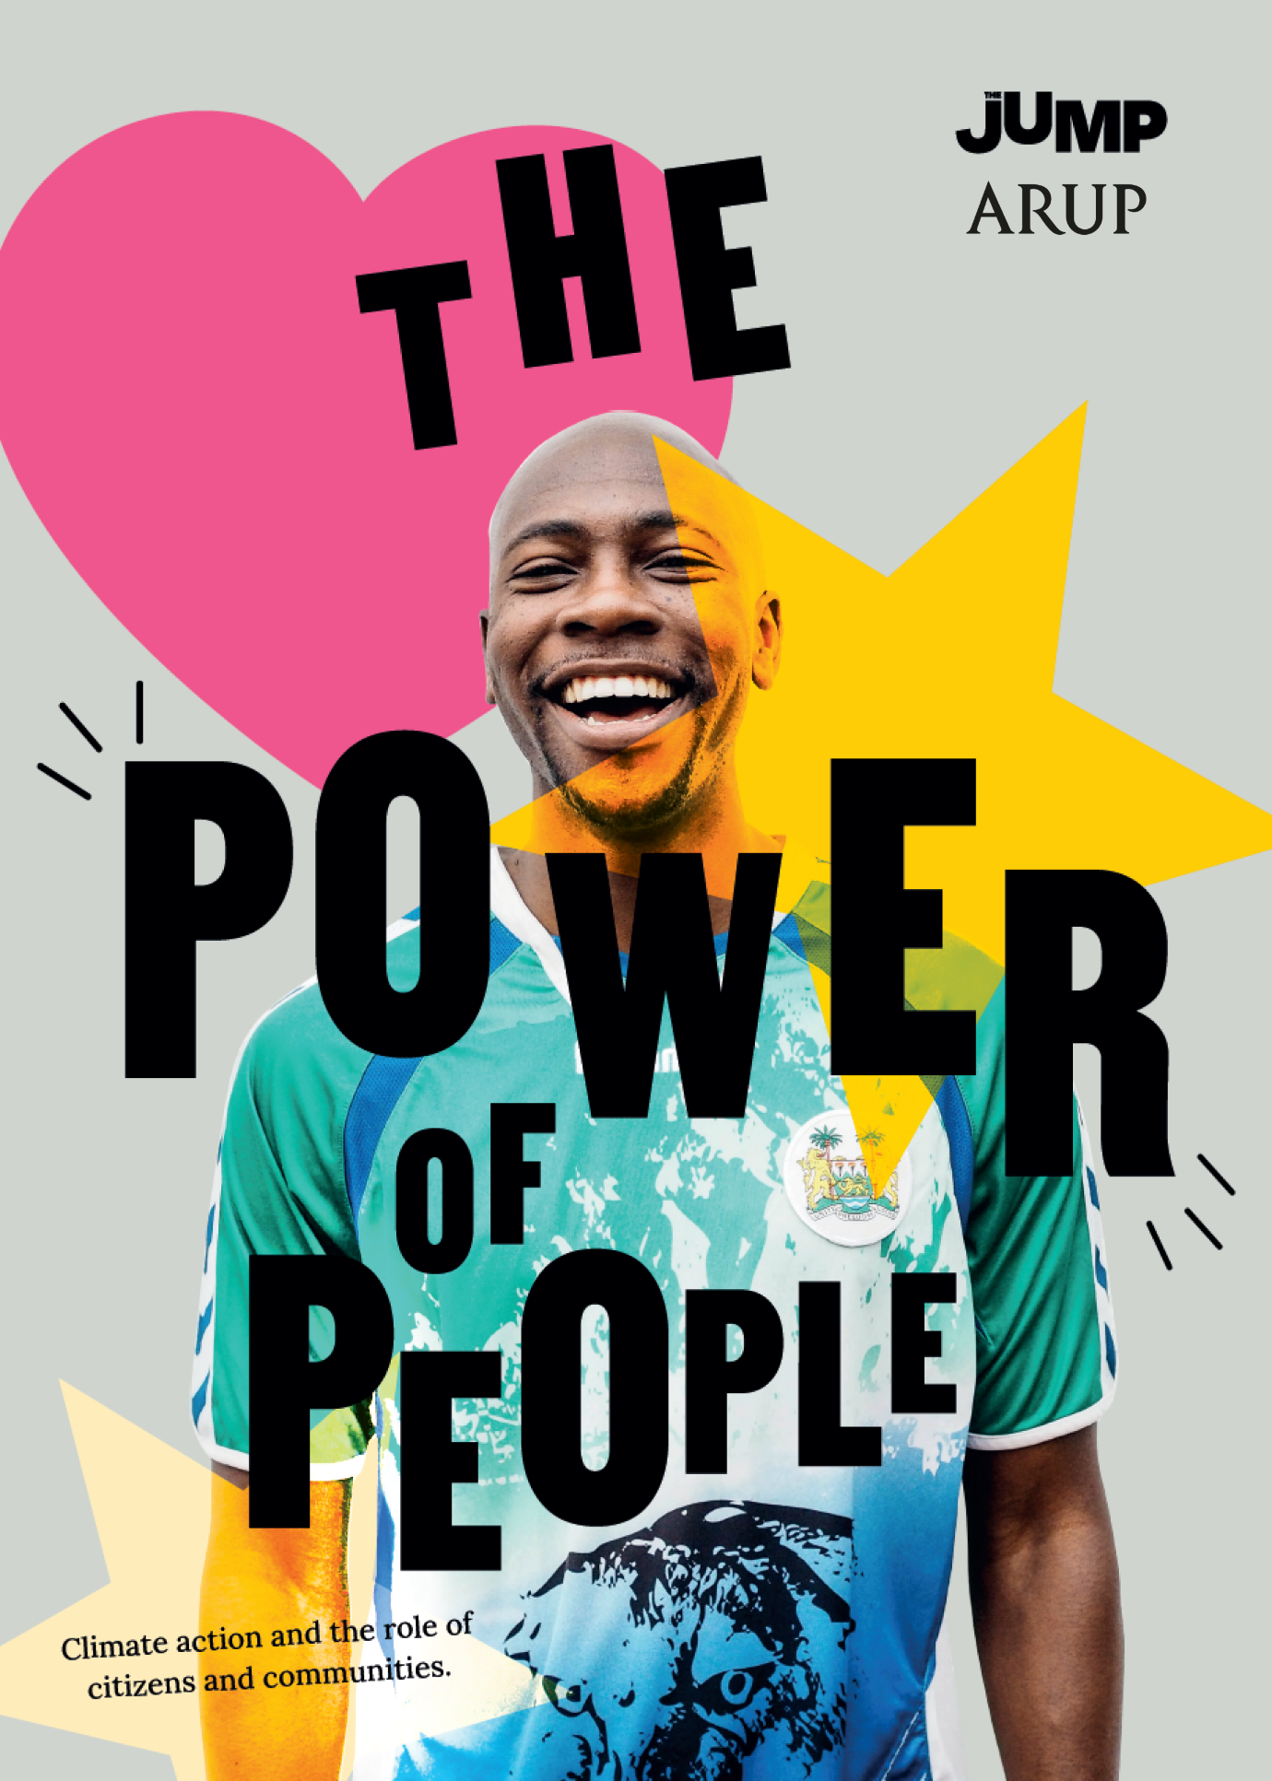
Inspiring and empowering new research finds individuals can make a huge difference to climate change

This brand-new scientific research - ‘The Power of People’ - asks the question, ‘is avoiding climate meltdown only about action by government and industry, with individuals effectively powerless? Or can citizens and communities have a meaningful and direct impact in the here and now?’ The research was requested by The JUMP, undertaken by Arup, overseen by C40 Cities, and based on evidence kindly provided by the University of Leeds. It found that:

“Government and industry do have most responsibility, but citizen and community action is meaningful, impactful, and urgently needed:

- Citizens have primary influence over 25-27% of the emissions savings needed by 2030 to avoid ecological meltdown. This is the first time this impact has been quantified and shows citizens are not powerless.
- At the same time, it is not up to citizens to ‘save the world’ on their own, government and business still have the largest responsibility, for up to 73-75%.
- The 25-27% is actually a minimum for the influence of citizens, since citizens can also have in-direct impact on the remaining 73-75% through influencing industry and government.
- Due to their capacity for quick action, efforts by citizens and communities are particularly important between now and 2030, the most important decade for climate action.
- For the changes led by citizens and communities, it is higher income groups that must take faster and bigger action. Action by lower-income need only influence 9% of savings”.

The research shows how citizens and communities can deliver these savings through six shifts:

- End clutter: Keep electronic products and home appliances for at least seven years
- Holiday local: One flight every three years
- Eat green: A plant-based diet, healthy portions, no waste
- Dress retro: Three new items of clothing per year
- Travel fresh: If you can, no personal vehicles
- Change the system: At least one life shift to nudge the system, like moving to a green energy company or a green pension supplier.

In response to this research a joyous, people-led movement called The JUMP is launching on 5th March to build a community of citizens supporting each other to make these shifts.

People can sign up to ‘take The JUMP’ at www.takethejump.org where they’ll get the tools and support to help along the way. [We’d be delighted if you could include this URL in any articles]

Notes to editors:
- The research and related digital assets will be shared under embargo on Monday 28th of Feb for launch on Monday 7th Jan 2022
- The research and The JUMP will be publicised at an event at 12noon, 5th March, at the wonderful community climate project ZERO, 14-16 Friary Street, QU1 4EH, Guildford, 12-2pm, live streamed here: facebook.com/takeTheJUMPnow
- Contact Tom Bailey, co-founder of the JUMP, for more information on: team@takethejump.org

